**How to set unit testing with Mocha and Chai for VS Code**

1. Open Visual Studio code.
2. In the terminal type npm init and press Enter

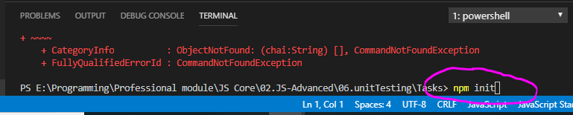

1. You will be asked multiple question just ignore questions by pressing Enter and confirm in the end by typing “yes”. And you will get package.json file

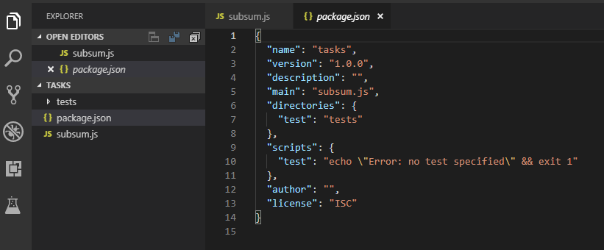

1. Again in the terminal type npm intsall mocha to install mocha locally for the current project folder. And then also install chai by typing in the terminal npm install chai

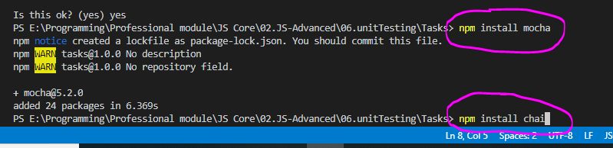

1. If you have done all correctly you should have node_modules folder and mocha and chai dependencies in the package.json file

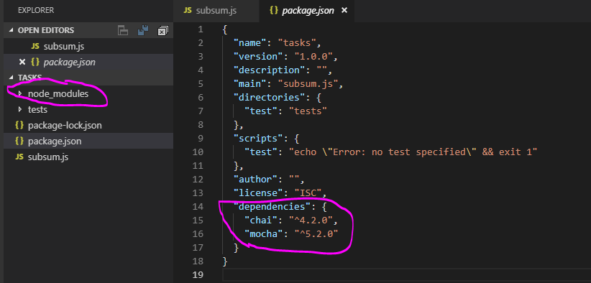

1. Click on the debugger tab in visual studio code and then click the small wheel icon

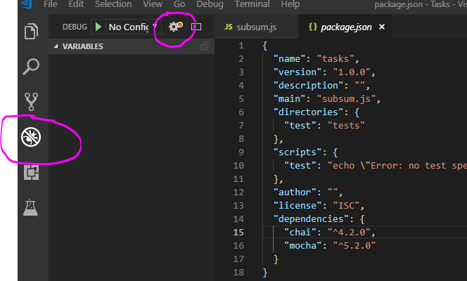

1. Click the Add Configuration button

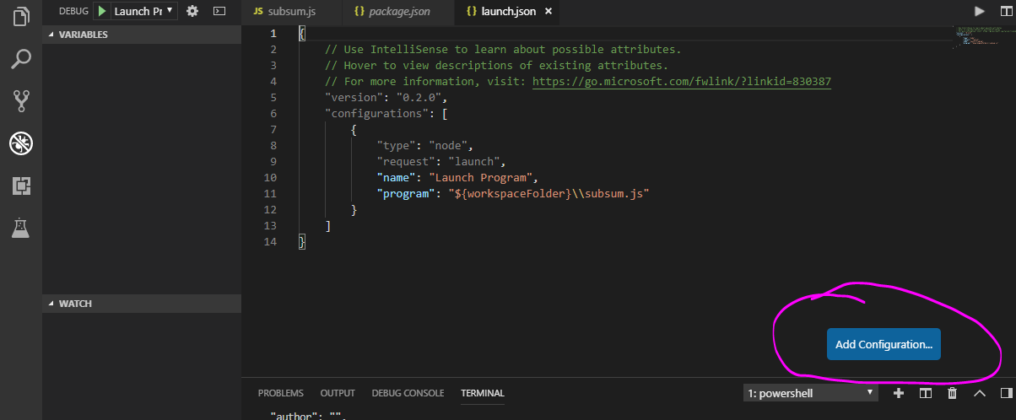

1. And from the options choose Node.js Mocha Tests

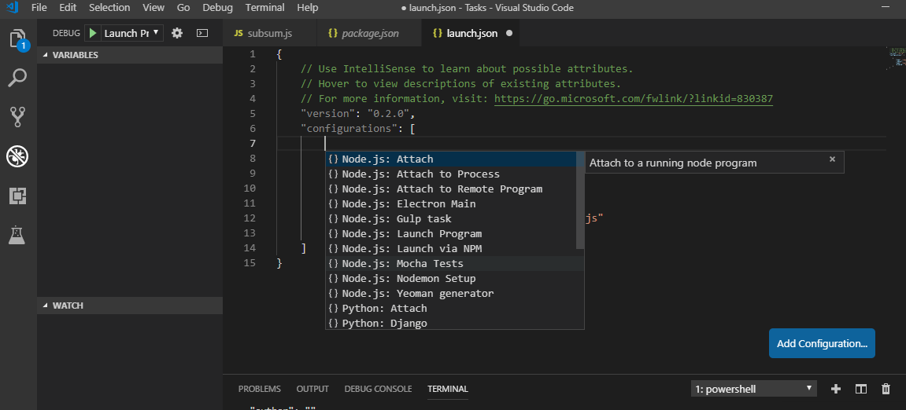

1. You will get the configuration and don’t forget to save it with ctrl + s. Note that you have to check which folder will be check for tests. By default it is folder named **test** in the current project folder

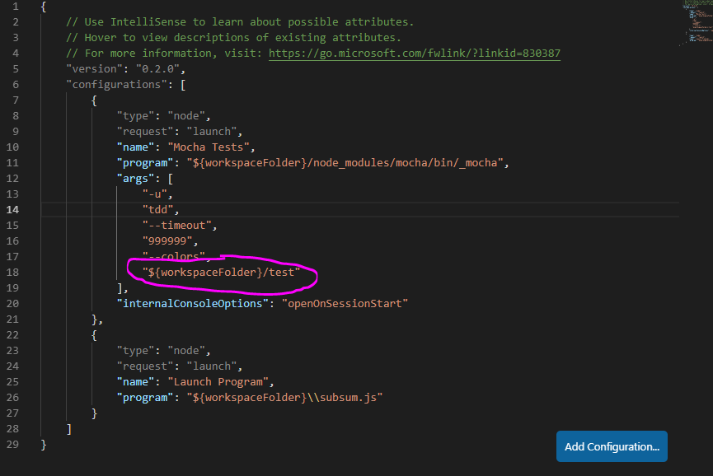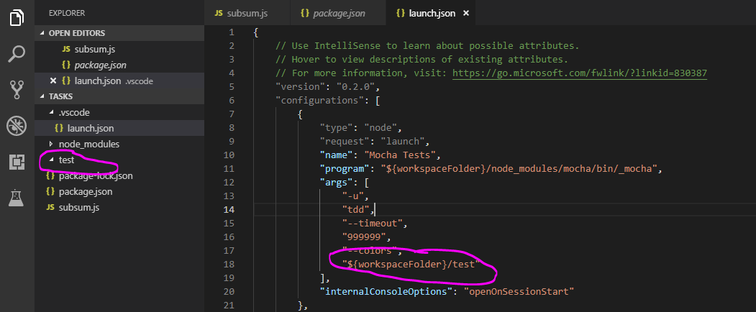

1. To run tests click the debugger tab icon in visual studio code and in the pane on the left select Mocha Tests from the dropdown menu

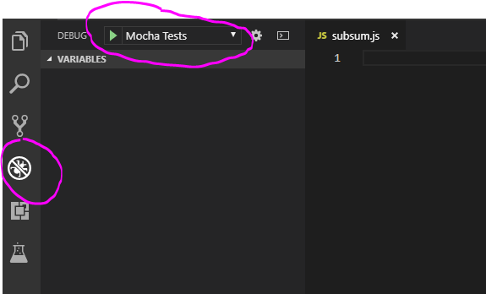

1. That’s it, if you press the green triangle you will run the tests in the test folder.
2. Pay attention for the directory in which your tests are placed. You can check for which directory will be searched in the package.json file after creating it:

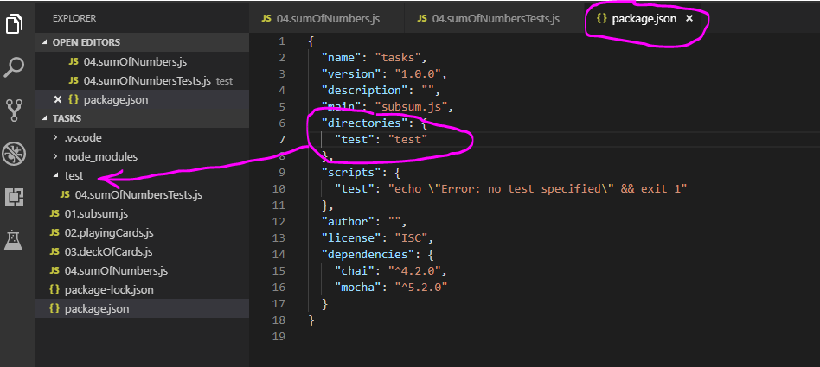

1. Only run the test folder by clicking the green triangle icon in VS code not by key combination, because it may result in error saying “describe is not defined”.
2. We can additionally also install jsdom and jquery to be able to run tests locally. To do that click in VS code on your package.json file and in the terminal type npm install jsdom

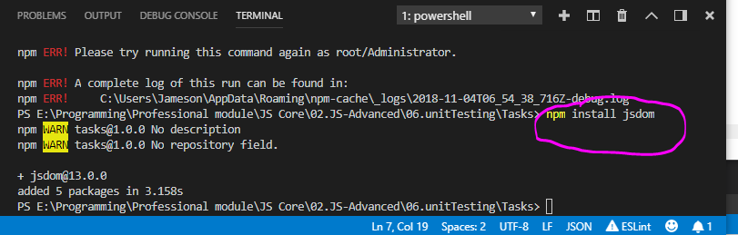

And now in your package.json file you should have the jsdom dependency. The same also install by typing in terminal npm install jsdom-global And now your dependencies should also have jsdom-global

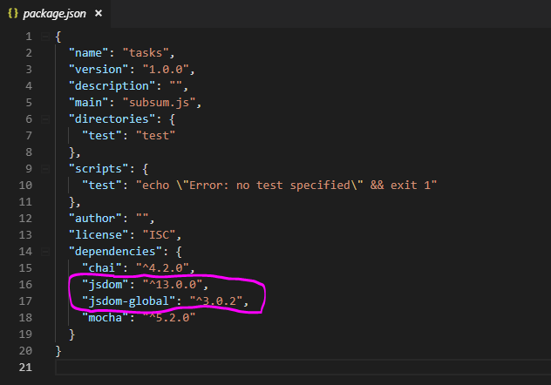

1. Next we can install and jQuery by typing in the terminal npm install jquery

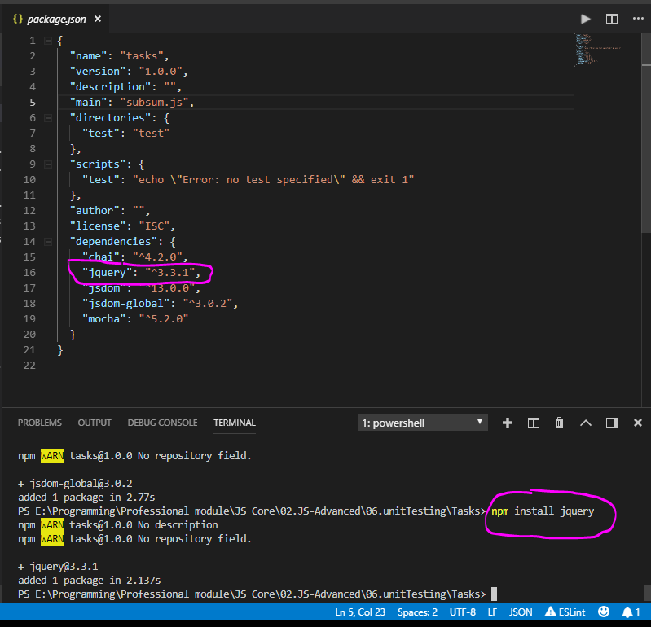

**Simple example of already working testing scenario**

1. Below is example of simple test scenario. First check how the js file holding the what will be tested look like for example.

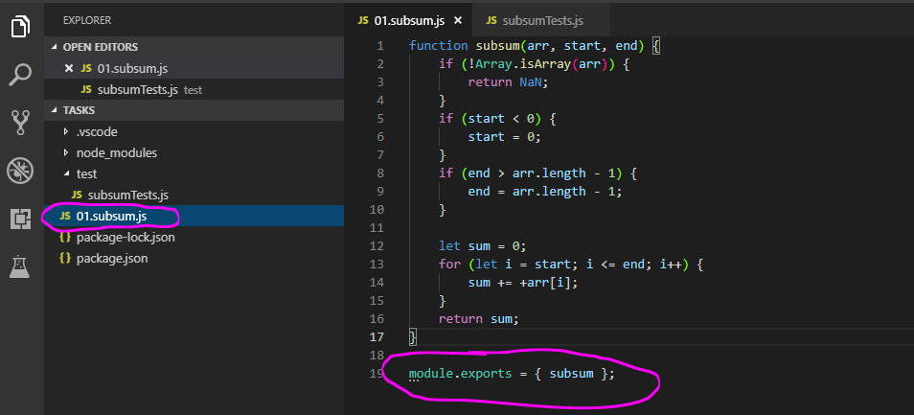

1. Now check how the js file holding tests look like for example

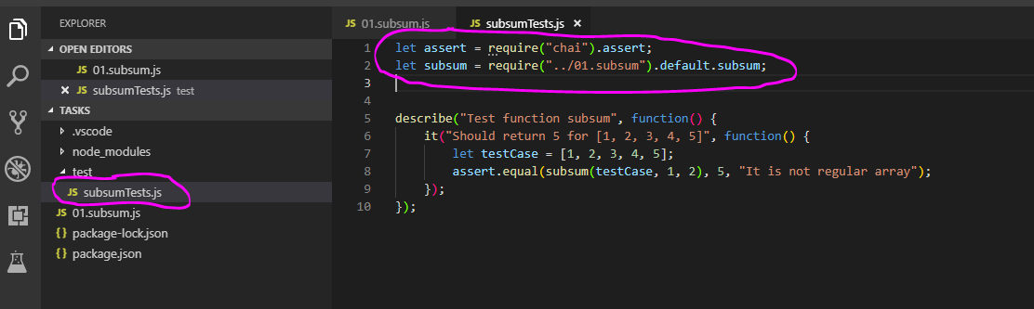

1. And click the green triangle to run the tests

